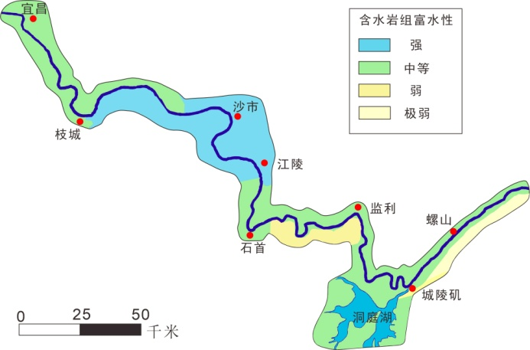
附图1 长江中游荆江段沿岸含水岩组富水性分布图
Fig.1 Distribution map of aquifer water-richness along the Jingjiang section of the middle reaches of the Yangtze River

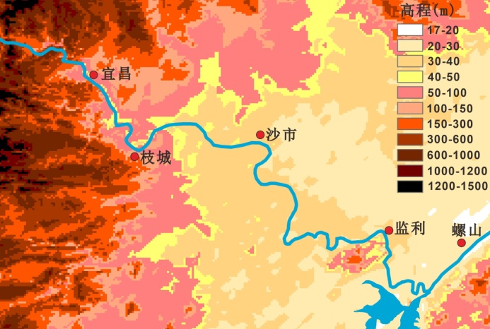
附图2 荆江段地表高程图
Fig.2 Surface elevation map of Jingjiang section

