附件
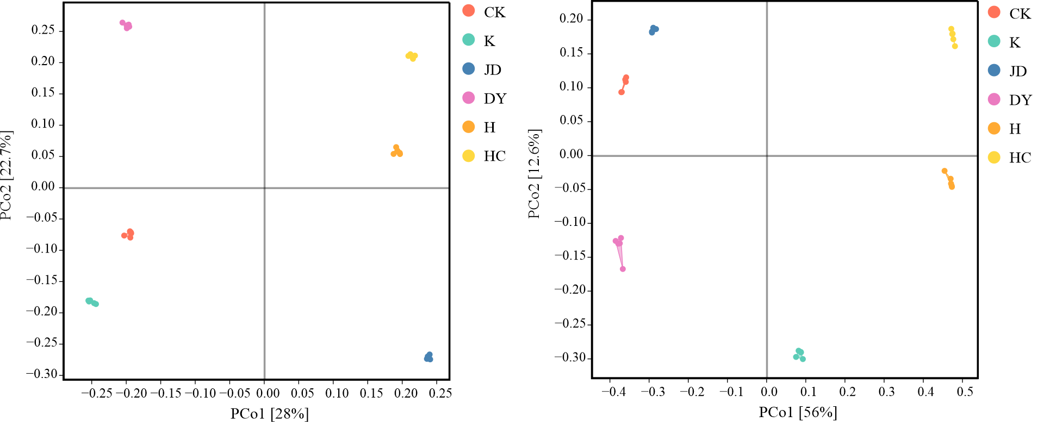
附图1 微生物群落β多样性变化
Attached figure S1 Changes in microbial community β-diversity
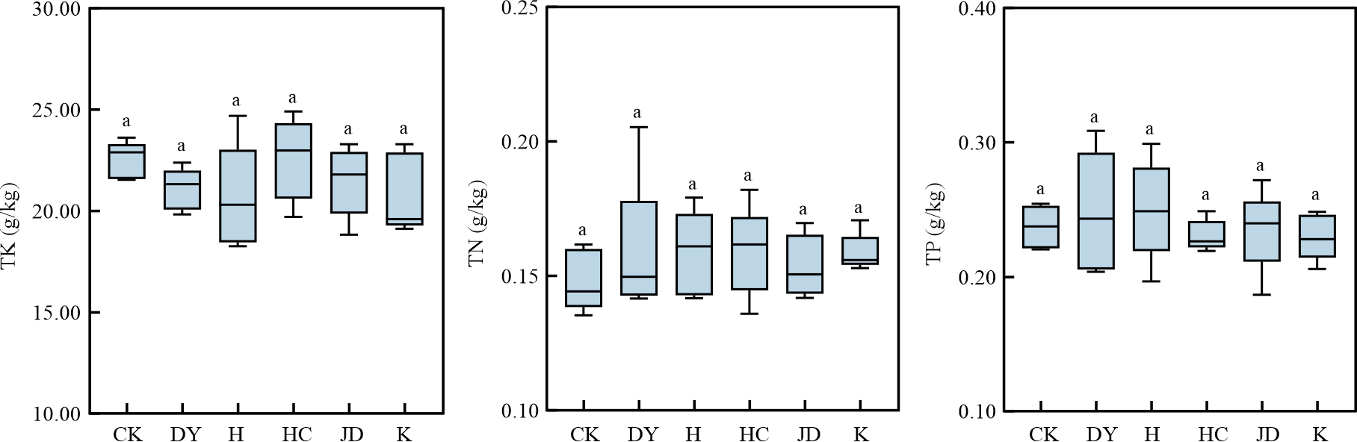
附图2 微生物影响下TBM洞渣总氮、总磷、总钾含量变化
Attached figure S2 Changes in total nitrogen, total phosphorus, and total potassium contents of TBM muck under microbial influence

