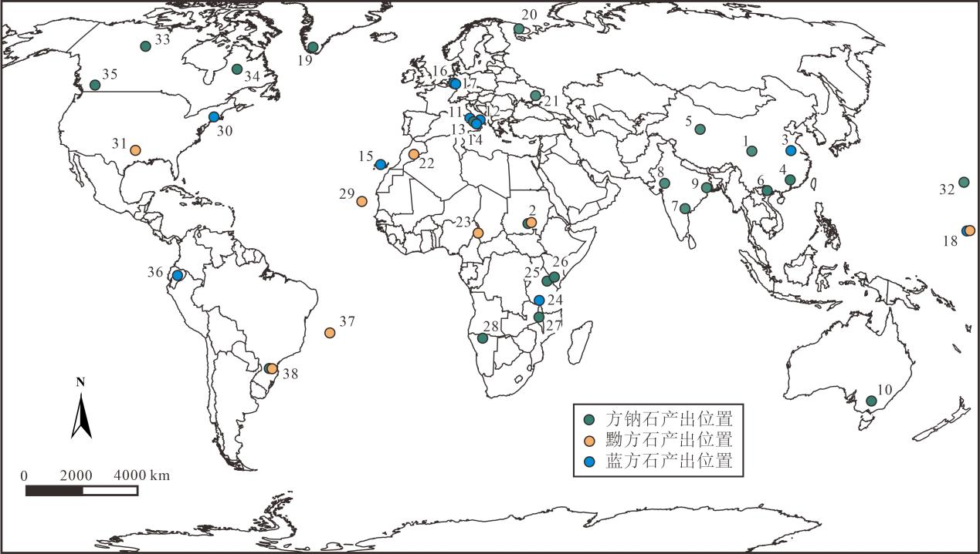

附图1 世界范围内方钠石族矿物的分布（底图据Marks and Markl, 2017修改）

Fig.S1 The distributions of SGM worldwide (base map modified after Marks and Markl, 2017)

# References

Marks, M. A. W., Markl, G., 2017. A Global Review on Agpaitic Rocks. *Earth-Science Reviews*, 173: 229-258. [https://doi. org/10. 1016/ j.earscirev.2017.06.002](https://doi.org/10.1016/j.earscirev.2017.06.002" \t "https://www.sciencedirect.com/science/article/pii/_blank" \o "Persistent link using digital object identifier)