**附录1**

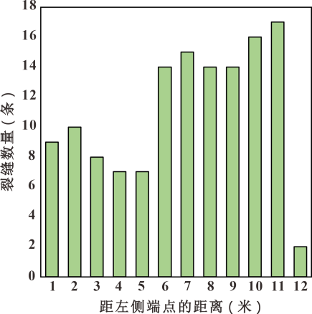

断裂带内部露头2中测线1的线密度分析图

Line density analysis of line 1 inoutcrop 2