附加文件
附加文件1. 角闪石族矿物分类命名图解及投点
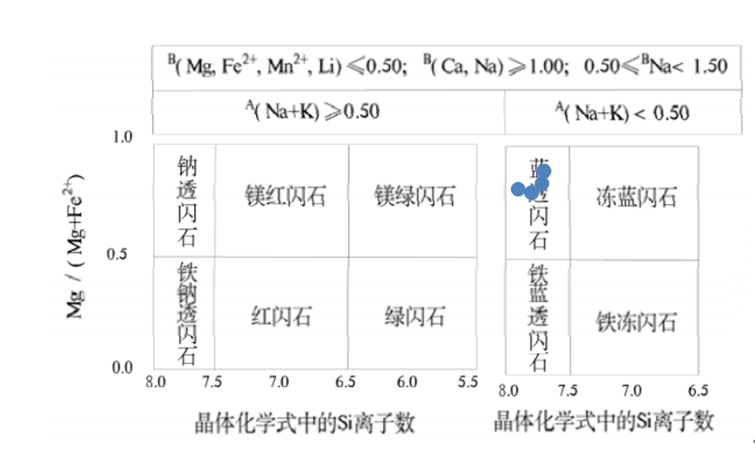
图1.1钠-钙角闪石组角闪石组的矿物分类命名图解及投点（刘显凡, 2015， 下同）
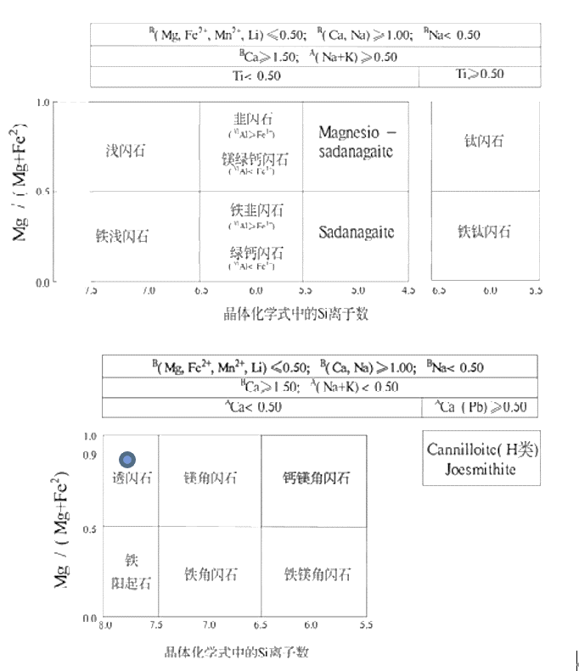
图1.2 钙角闪石组的矿物分类命名图解及投点
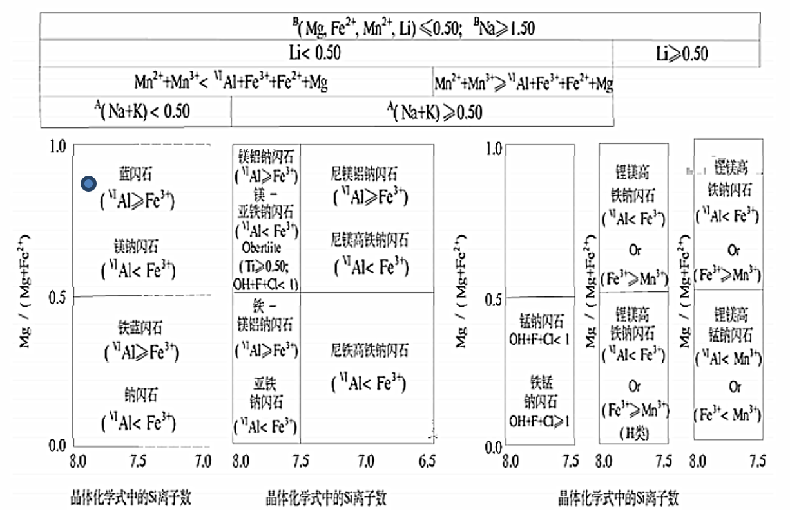
图1.3钠角闪石组的矿物分类命名图解及投点

附加文件2.
表5 金红石出溶体与斜黝帘石主晶的结晶学对应关系
Table 6. CORs between rutile inclusions and clinozoisite
薄片名称 | 颗粒名称 | 出溶体名称 |  | 结晶学对应关系
HA-  10 | 颗粒1 | Rt-1-2 |  | {001}_{Rt} // {010}_{Czo}  {100}_{Rt} // {001}_{Czo}
 |  | Rt-4-6 |  | {001}_{Rt} // {010}_{Czo}  {110}_{Rt} //<001>_{Czo}
 | 颗粒2 | Rt-8 |  | ——*
 |  | Rt-9-10-11 |  | {001}_{Rt} // {100}_{Czo}  {110}_{Rt} //<001>_{Czo}  {111}_{Rt} // {110}_{Czo}
 | 颗粒3 | Rt-12-15-16-19-23 |  | {110}_{Rt} //{001}_{Czo}
 |  | Rt-13 |  | {011}_{Rt} //<100>_{Czo}
 |  | Rt-14 |  | {001}_{Rt} // {010}_{Czo}  {110}_{Rt} //<001>_{Czo}
 |  | Rt-17 |  | {001}_{Rt} // {010}_{Czo}  {110}_{Rt} //<001>_{Czo}  {111}_{Rt} // {111}_{Czo}
 |  | Rt-18 |  | {110}_{Rt} //<001>_{Czo【近】}
 |  | Rt-21 |  | ————
 |  | Rt-22 |  | {110}_{Rt} //{001}_{Czo}
 |  | Rt-25 |  | {110}_{Rt} //{001}_{Czo}  {011}_{Rt} //{110}_{Czo}
 |  | Rt-26 |  | {100}_{Rt} //{001}_{Czo【近】}
 | 颗粒4 | Rt-33 |  | {100}_{Rt} //{001}_{Czo}  {001}_{Rt} //{010}_{Czo}
 |  | Rt-34 |  | {100}_{Rt} //{110}_{Czo}
 |  | Rt-37 |  | {111}_{Rt} //{100}_{Czo}
 |  | Rt-49 |  | {111}_{Rt} //<001>_{Czo}  {301}_{Rt} //{001}_{Czo}
 |  | Rt-35-36-45-46-47-48 |  | {100}_{Rt}//<001>_{Czo}  {111}_{Rt} //<100>_{Czo}
HA-10-a | 区域1 | Rt-1-3-4-12-13 |  | {001}_{Rt} // {111}_{Czo}  {301}_{Rt} //<001>_{Czo}  {011}_{Rt} // {010}_{Czo}
 | 区域2 | Rt-14 |  | {301}_{Rt} //<001>_{Czo【近】}
 |  | Rt-15 |  | {110}_{Rt} // <001>_{Czo}
 |  | Rt-16-18 |  | {301}_{Rt} //<001>_{Czo}  {001}_{Rt} // {111}_{Czo}
 |  | Rt-17 |  | {100}_{Rt} //<001>_{Czo}
 | 区域3 | Rt-32 |  | {100}_{Rt} //<001>_{Czo}  {110}_{Rt} // {001}_{Czo}
 |  | Rt-33-34-35-36-37 |  | {001}_{Rt} // {100}_{Czo}  {100}_{Rt} //<001>_{Czo}  {100}_{Rt} // {010}_{Czo}
 | 区域4 | Rt-44-58-60 |  | {011}_{Rt} // {100}_{Czo}
 |  | Rt-45 |  | ——
 |  | Rt-46 |  | ——
 |  | Rt-47 |  | {301}_{Rt} // <100>_{Czo}
 |  | Rt-48-57 |  | {001}_{Rt} // {100}_{Czo}  {100}_{Rt} // <001>_{Czo}  {100}_{Rt} // {010}_{Czo}  {111}_{Rt} // {111}_{Czo}
 |  | Rt-59 |  | {301}_{Rt} // {001}_{Czo}  {110}_{Rt} // {111}_{Czo}
 | 区域5 | Rt-61-63 |  | {110}_{Rt} // <001>_{Czo}
 | 区域6 | Rt-67 |  | ——
 |  | Rt-68 |  | {110}_{Rt} // {110}_{Czo}
 |  | Rt-69 |  | {100}_{Rt} // <001>_{Czo}
 |  | Rt-70 |  | {110}_{Rt} // <001>_{Czo}  {111}_{Rt} // {111}_{Czo}
 |  | Rt-71 |  | {110}_{Rt} // <001>_{Czo}  {111}_{Rt} // {110}_{Czo}
 |  | Rt-72 |  | {110}_{Rt} // {110}_{Czo}  {111}_{Rt} // <001>_{Czo}
 |  | Rt-73 |  | {001}_{Rt} // {100}_{Czo}  {110}_{Rt} // <001>_{Czo}
 |  | Rt-74 |  | {110}_{Rt} //<100>_{Czo}  {111}_{Rt} // {010}_{Czo}
 |  | Rt-75 |  | {110}_{Rt} // {001}_{Czo}
 |  | Rt-76 |  | {301}_{Rt} //<001>_{Czo}
 |  | Rt-77 |  | ——
 | 区域7 | Czo(91-95) | Rt-87 | ——
 |  |  | Rt-88-89-90 | {301}_{Rt} //<001>_{Czo}  {301}_{Rt} // {100}_{Czo}
 |  | Czo(101-106) | Rt-96-97-98-99-100 | {001}_{Rt} // {110}_{Czo}  {301}_{Rt} //<001>_{Czo【近】}
HA-10-b | Q1-1 | Rt-1-2-5-6-8-9 |  | {110}_{Rt} //{001}_{Czo}  {001}_{Rt} //{110}_{Czo}
 |  | Rt-3 |  | {100}_{Rt} //<001>_{Czo}  {011}_{Rt} //{100}_{Czo}
 |  | Rt-4 |  | ——
 |  | Rt-7 |  | {110}_{Rt} //{001}_{Czo}  {011}_{Rt} //{010}_{Czo}
 | Q1-2 | Rt-47 |  | {011}_{Rt} //<100>_{Czo}
 |  | Rt-48 |  | {011}_{Rt} //<100>_{Czo}  {100}_{Rt} //{001}_{Czo}
 |  | Rt-49-50-52-53-65-66  -68 |  | {100}_{Rt} //<001>_{Czo}  {011}_{Rt} //{100}_{Czo}  {301}_{Rt} //{010}_{Czo}
 |  | Rt-51 |  | {111}_{Rt} //<001>_{Czo}  {011}_{Rt} //<100>_{Czo}
 |  | Rt-67 |  | {100}_{Rt} //<001>_{Czo}  {100}_{Rt} //{100}_{Czo}
 |  | Rt-69 |  | {100}_{Rt} //<001>_{Czo}
 | Q1-3 | Rt-20-21-22-24-26-27 |  | {301}_{Rt} //<001>_{Czo}  {011}_{Rt} //{010}_{Czo}
 |  | Rt-18 |  | {111}_{Rt} //<001>_{Czo}  {301}_{Rt} //{010}_{Czo}
HA-10-b |  | Rt-19-25 |  | {001}_{Rt} //{010}_{Czo}  {100}_{Rt} //<001>_{Czo}
 |  | Rt-23 |  | {011}_{Rt} //{010}_{Czo【近】}  {100}_{Rt} //<100>_{Czo}
 | Q1-4 | Rt-38 |  | {001}_{Rt} //<001>_{Czo}  {110}_{Rt} //<100>_{Czo}
 |  | Rt-39 |  | {001}_{Rt} //{001}_{Czo}
 |  | Rt-40 |  | {001}_{Rt} //{001}_{Czo}
 | Q2-1 | Rt-74 |  | {110}_{Rt} //<001>_{Czo}  {001}_{Rt} //{010}_{Czo}
 | Q2-2 | Rt-81-82-83 |  | {110}_{Rt} //{001}_{Czo}
 |  | Rt-84 |  | {301}_{Rt} //<001>_{Czo}
 |  | Rt-85 |  | ——
 |  | Rt-86 |  | {301}_{Rt} //<001>_{Czo}
 |  | Rt-94 |  | {001}_{Rt} //{010}_{Czo}  {100}_{Rt}//<100>_{Czo}  {100}_{Rt}//{001}_{Czo}
 |  | Rt-95 |  | {301}_{Rt} //<001>_{Czo}  {100}_{Rt} //{110}_{Czo}  {011}_{Rt} //<100>_{Czo}
 |  | Rt-96 |  | {001}_{Rt} //{010}_{Czo}  {100}_{Rt} //<001>_{Czo}  {100}_{Rt}//{001}_{Czo}
 |  | Rt-97 |  | {301}_{Rt} //<001>_{Czo}  {100}_{Rt}//{110}_{Czo}
 | Q3-1 | Rt-102-103 |  | {100}_{Rt} //{110}_{Czo}
 |  | Rt-104-105 |  | {301}_{Rt} //<001>_{Czo}
 |  | Rt-106 |  | ——
 |  | Rt-107 |  | ——
 |  | Rt-108-109-110-111-127-128 |  | {011}_{Rt} //{010}_{Czo}  {100}_{Rt} //{101}_{Czo【罕】}
 |  | Rt-112 |  | {100}_{Rt} //{001}_{Czo}  {011}_{Rt} //<100>_{Czo}
 |  | Rt-113 |  | {110}_{Rt} //<100>_{Czo}
 |  | Rt-114-115 |  | {301}_{Rt} //<001>_{Czo}  {111}_{Rt} //{111}_{Czo}
 |  | Rt-116 |  | {301}_{Rt} //{001}_{Czo}
 |  | Rt-117-118 |  | {011}_{Rt} //{110}_{Czo}
HA-10-b |  | Rt-119-130-131-141-142-143-144-145 |  | {001}_{Rt} //{010}_{Czo}  {110}_{Rt} //<100>_{Czo}
 |  | Rt-129 |  | {100}_{Rt} //{101}_{Czo【罕】}  {011}_{Rt} //{110}_{Czo}
 |  | Rt-132-133 |  | {110}_{Rt} //{001}_{Czo}
 |  | Rt-134 |  | {301}_{Rt} //<001>_{Czo}  {001}_{Rt} //{010}_{Czo}
 |  | Rt-135 |  | {111}_{Rt} //{110}_{Czo}
 |  | Rt-136 |  | ——
 |  | Rt-146-147 |  | {001}_{Rt} //{010}_{Czo}  {110}_{Rt} //<100>_{Czo}
 | Q3-2 | Rt-154-155 |  | {001}_{Rt} //{010}_{Czo}  {110}_{Rt} //<001>_{Czo}
 |  | Rt-156-161-162-163-164-165-166-167 |  | {110}_{Rt} //<001>_{Czo}  {011}_{Rt} //{010}_{Czo}
 |  | Rt-157-158 |  | {001}_{Rt} //{010}_{Czo}  {110}_{Rt} //<001>_{Czo}  {100}_{Rt} //{001}_{Czo}
 |  | Rt-159-160 |  | {001}_{Rt} //{010}_{Czo}  {110}_{Rt} //<001>_{Czo}
 |  | Rt-176-177-179 |  | {001}_{Rt} //{010}_{Czo}  {110}_{Rt} //{001}_{Czo}  {100}_{Rt} //{101}_{Czo}
 |  | Rt-178 |  | {100}_{Rt} //{001}_{Czo【近】}  {301}_{Rt} //<001>_{Czo}
 | Q3-3 | Rt-184 |  | {011}_{Rt} //{010}_{Czo}
 |  | Rt-185 |  | {111}_{Rt} //{110}_{Czo}  {301}_{Rt} //<001>_{Czo}
 |  | Rt-186 |  | ——
 | Q3-4 | Rt-194-195 |  | {001}_{Rt} //{11-1}_{Czo}  {011}_{Rt} //{110}_{Czo}
 |  | Rt-196-197-198-199-200-201-202-208-209-215-216-217-218 |  | {301}_{Rt} //<001>_{Czo}  {110}_{Rt} //{102}_{Czo}  {111}_{Rt} //{010}_{Czo}
 |  | Rt-204 |  | {001}_{Rt} //{010}_{Czo}  {110}_{Rt} //{001}_{Czo}  {100}_{Rt} //<001>_{Czo}  {011}_{Rt} //{110}_{Czo}
HA-10-b |  | Rt-205 |  | {001}_{Rt} //{010}_{Czo}  {100}_{Rt} //<100>_{Czo}
 |  | Rt-206 |  | {001}_{Rt} //{010}_{Czo【近】}  {110}_{Rt} //{001}_{Czo【近】}
 |  | Rt-207 |  | {100}_{Rt} //{001}_{Czo}  {001}_{Rt} //{010}_{Czo【近】}
 |  | Rt-210 |  | {111}_{Rt} //<001>_{Czo}
 |  | Rt-211-212-214 |  | {110}_{Rt} //<001>_{Czo}  {001}_{Rt} //{110}_{Czo}
 |  | Rt-213 |  | ——
 | Q3-6 | Rt-229-230-231-234-239-243-244-250-251-253-254-255 |  | {301}_{Rt} //<001>_{Czo【近】}  {001}_{Rt} //{102}_{Czo}
 |  | Rt-228 |  | {001}_{Rt} //{001}_{Czo【近】}
 |  | Rt-232 |  | {111}_{Rt} //{001}_{Czo}  {111}_{Rt} //{100}_{Czo}
 |  | Rt-233-242 |  | {301}_{Rt} //<001>_{Czo【近】}  {301}_{Rt} //{010}_{Czo}
 |  | Rt-237 |  | {001}_{Rt} //{001}_{Czo}  {110}_{Rt} //{110}_{Czo【近】}
 |  | Rt-238 |  | {001}_{Rt} //{001}_{Czo}  {110}_{Rt} //{010}_{Czo}  {110}_{Rt} //<100>_{Czo}
 |  | Rt-241 |  | {110}_{Rt} //<001>_{Czo}
 |  | Rt-245-246-247 |  | {301}_{Rt} //<001>_{Czo}  {111}_{Rt} //{110}_{Czo}
 |  | Rt-248-249 |  | {011}_{Rt} //{100}_{Czo}  {111}_{Rt} //{001}_{Czo}
 |  | Rt-252 |  | {301}_{Rt} //<001>_{Czo}
 | Q4-1 | Rt-270-271 |  | {301}_{Rt} //{110}_{Czo}
 |  | Rt-272-277-282 |  | {011}_{Rt} //{010}_{Czo}  {001}_{Rt} //{111}_{Czo}
 |  | Rt-273 |  | ——
 |  | Rt-274 |  | {301}_{Rt} //{100}_{Czo}
 |  | Rt-275-276-278-279  -281 |  | {301}_{Rt} //<001>_{Czo}  {100}_{Rt} //{010}_{Czo}  {001}_{Rt} //{101}_{Czo}  {011}_{Rt} //{001}_{Czo}
HA-10-b |  | Rt-280 |  | {001}_{Rt} //{010}_{Czo}  {110}_{Rt} //<100>_{Czo}
 | Q4-2 | Rt-290-291-292 |  | {111}_{Rt} //<001>_{Czo}  {100}_{Rt} //<100>_{Czo}  {011}_{Rt} //{001}_{Czo}
 |  | Rt-293-294-304-305-309 |  | {110}_{Rt} //<100>_{Czo}
 |  | Rt-295 |  | {100}_{Rt} //<001>_{Czo}  {001}_{Rt} //{110}_{Czo}
 |  | Rt-296 |  | ——
 |  | Rt-297 |  | {110}_{Rt} //<100>_{Czo}
 |  | Rt-298-299-300 |  | {001}_{Rt} //<001>_{Czo【近】}
 |  | Rt-301 |  | {001}_{Rt} //{010}_{Czo}  {110}_{Rt} //<001>_{Czo}  {110}_{Rt} //{100}_{Czo}
 |  | Rt-302-308 |  | {001}_{Rt} //{010}_{Czo}  {110}_{Rt} //<001>_{Czo}
 |  | Rt-303 |  | {301}_{Rt} //<001>_{Czo}  {011}_{Rt} //{010}_{Czo}
 |  | Rt-306 |  | ——
 |  | Rt-307-310 |  | {001}_{Rt} //<001>_{Czo}  {100}_{Rt} //{010}_{Czo}  {100}_{Rt} //{100}_{Czo}  {110}_{Rt} //{110}_{Czo}  {011}_{Rt} //{001}_{Czo}
 |  | Rt-311 |  | {110}_{Rt} //{100}_{Czo}
 | Q4-3 | Rt-321-322 |  | {001}_{Rt} //{010}_{Czo}  {100}_{Rt} //<001>_{Czo}  {100}_{Rt} //{100}_{Czo}  {111}_{Rt} //{11-1}_{Czo}  {110}_{Rt} //{102}_{Czo}
 |  | Rt-323-324 |  | {001}_{Rt} //{010}_{Czo}  {100}_{Rt} //<001>_{Czo}
 |  | Rt-325 |  | {100}_{Rt} //{110}_{Czo}
 |  | Rt-330 |  | {011}_{Rt} //{100}_{Czo}
 |  | Rt-326 |  | {111}_{Rt} //{102}_{Czo}
 |  | Rt-327 |  | {100}_{Rt} //<001>_{Czo}
HA-10-b | Q4-3 | Rt-328 |  | ——
 |  | Rt-329 |  | {011}_{Rt} //{010}_{Czo}  {100}_{Rt} //{001}_{Czo}  {001}_{Rt} //{11-1}_{Czo}
 | Q4-4 | Rt-332-333-334-337 |  | {100}_{Rt} //<001>_{Czo}  {001}_{Rt} //{010}_{Czo}
*“——”表示金红石出溶体和斜黝帘石主晶无明显结晶学对应关系

